**Jenkins Introduction**

1. How to change Home Directory (win)

Default home folder

C:\Users\Anandhi\.jenkins

To change the home folder, (to have more space to store all the jobs)

Create a folder in any drive, copy the content of .jenkins to new folder.

And set JENKINS_HOME to new folder.

After path change, restart Jenkins either by

* 1. > java -jar Jenkins.war

Or

1. Explain about Jenkins Plugins

Goto Manage Jenkins -> Manage Plugins

Discuss about 4 tabs

1. Create a Free Style job – ‘SampleJob1’, to print.
   1. In window either

Goto Build -> Execute Window Batch command

echo Sample First Job....

(or )

* 1. Goto Build -> Execute Shell and include

Date

echo "Sample First Job...."

1. To generate log file while executing a job, install ‘Audit Trail’ plugin
   1. Install ‘Audit Trail’ plugin
   2. Once installed, restart Jenkins.
   3. Now we can configure ‘audit trail’ from Configure System
   4. To generate logfile on executing job, Select log file and

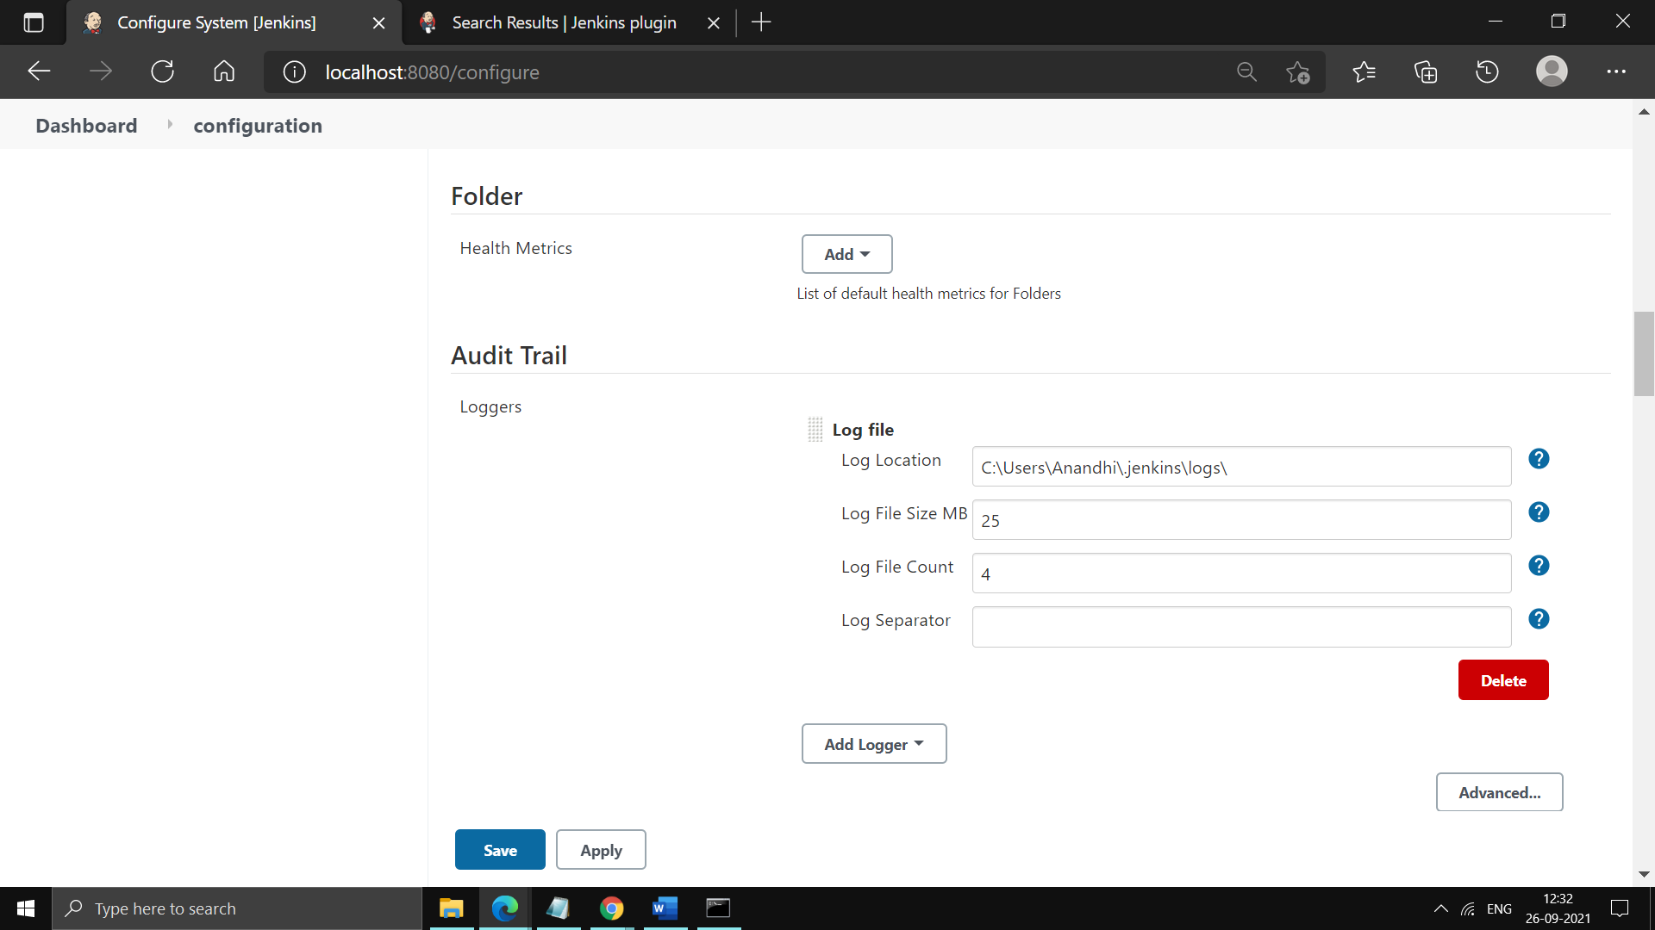

* 1. Now run the job, this will generate a log file under the given folder.

1. How to setup Git on Jenkins

Show Git Plugins

To integrate first setup GIT from Global Tool configuration

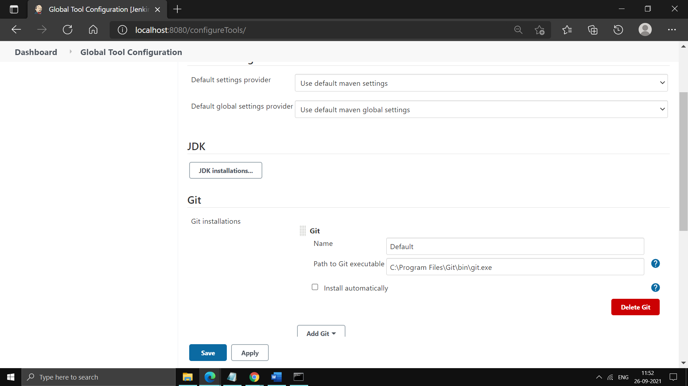

1. How to connect to Git Repository
   1. Create a new job
   2. Login into Github and copy repo url
   3. Under Source Code Management, add Github repo url
2. Now to add Credentials

Provide Github credentials

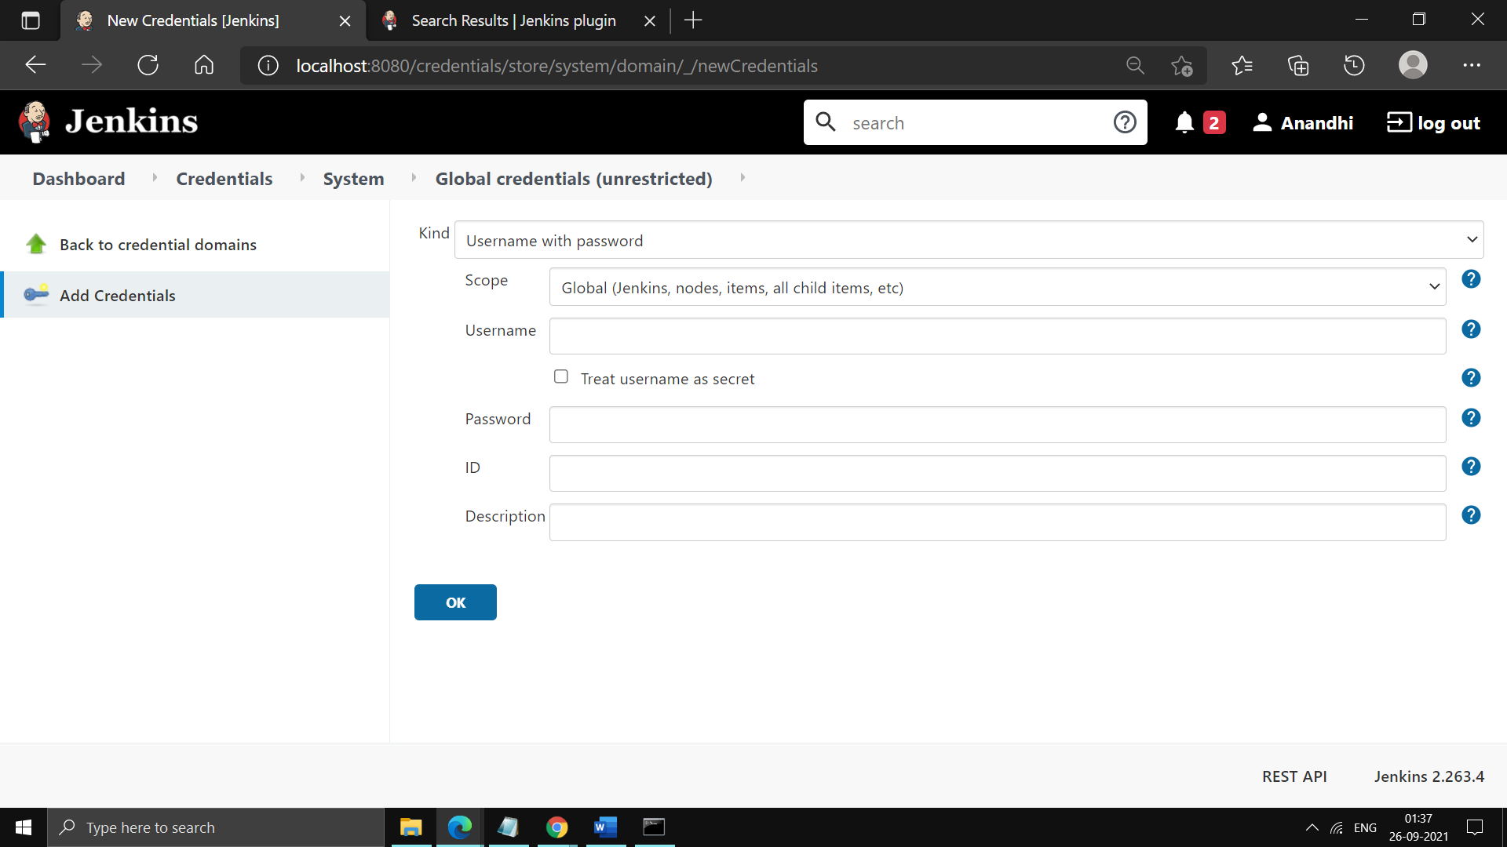

1. Run this job and this will clone a repository in Jenkins workspace. Show the files in project’s workspace.

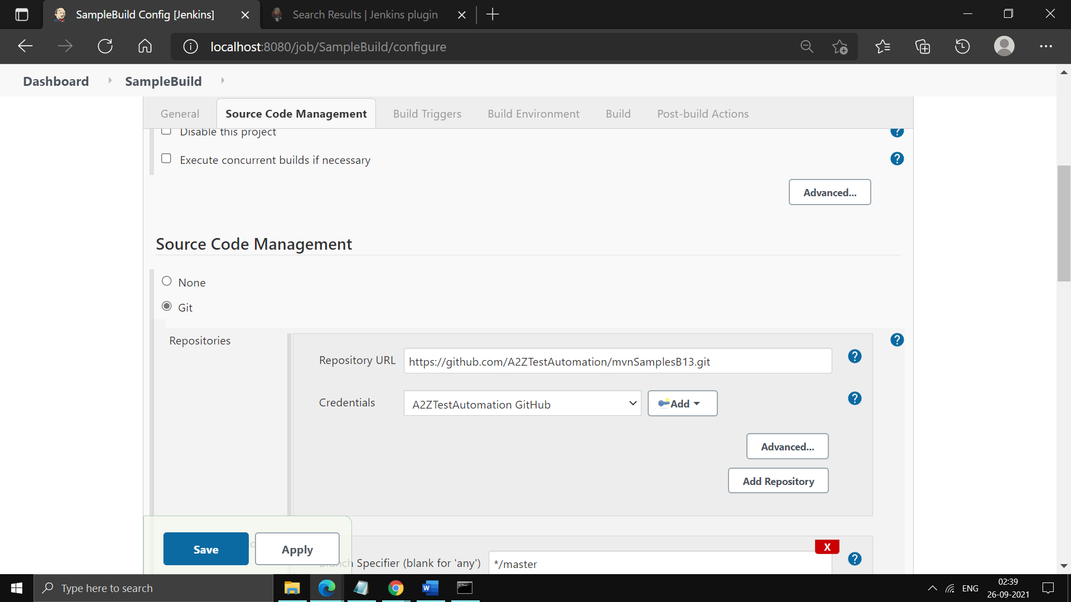

1. Use custom Job Workspace
   1. If we want to clone this project in custom workspace, configure
   2. 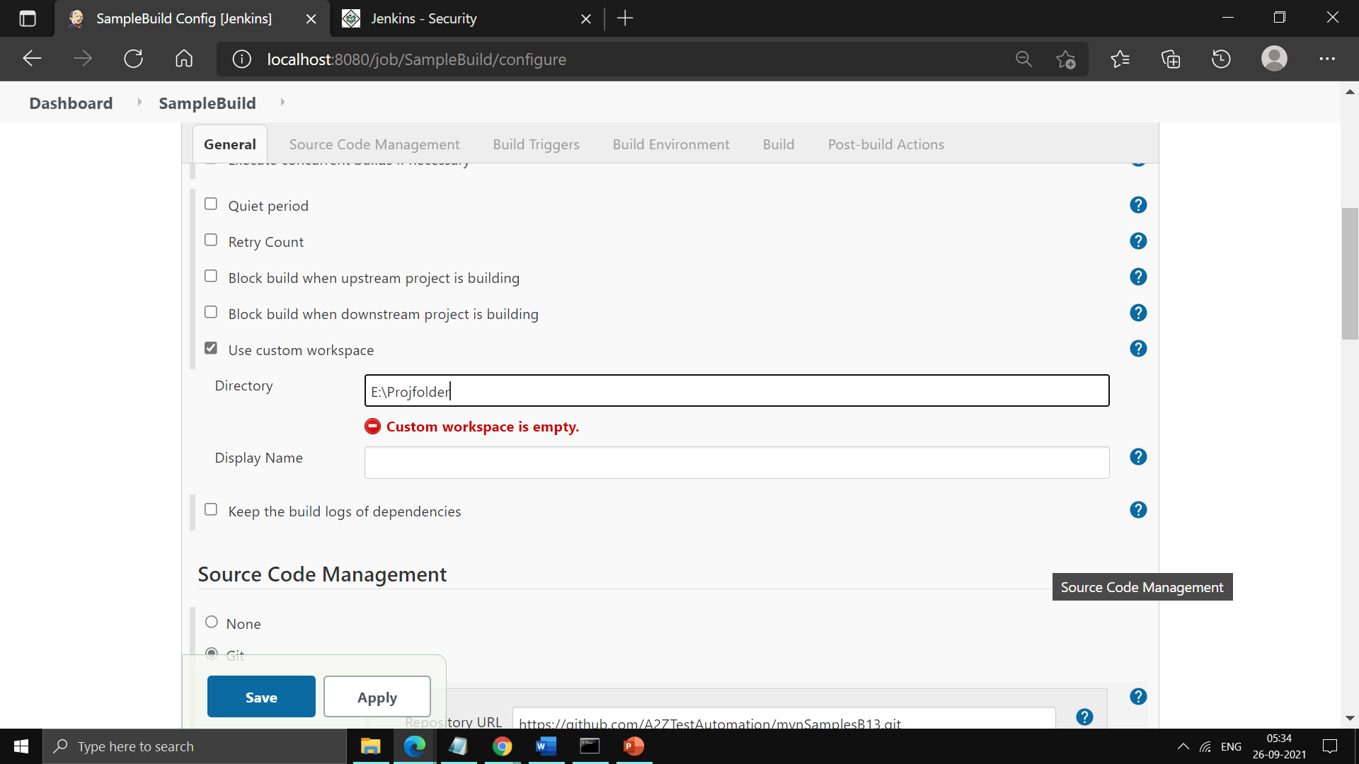
2. Setting Upstream and downstream :
   1. Created 3 jobs namely BuildUser, TestUser and ReleaseUser
   2. We want execute BuildUser -> TestUser -> ReleaseUser
   3. In BuildUser job,

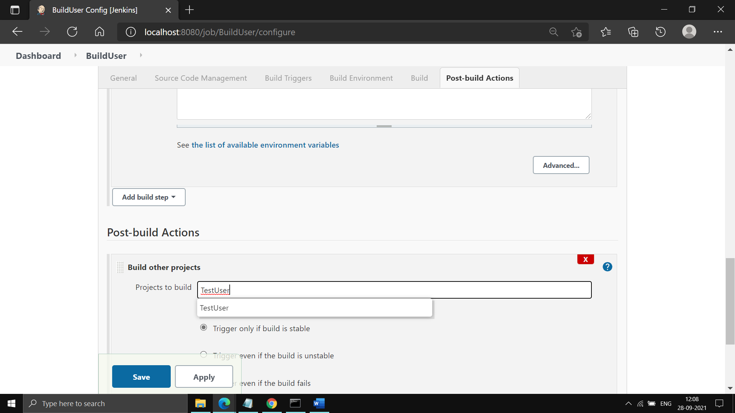

* 1. In TestUser job,

In Build Trigger -> Build after other projects are built -> BuildUser

In Post Build Action -> Build Other Projects -> ReleaseUser

* 1. Now running BuildUser job, will run TestUser and ReleaseUser….
  2. Now Goto Dashboad, Right click on ‘BuildUser’ and build. This will run TestUser and ReleaseUser.
  3. Once we have set the chain, we can create a pipeline.

1. Build Pipeline
   1. To build pipeline, install ‘Build Pipeline ’ plugin.
   2. Create a new pipeline and set ‘BuildUser’ as Initial job.
   3. Explain about all options.

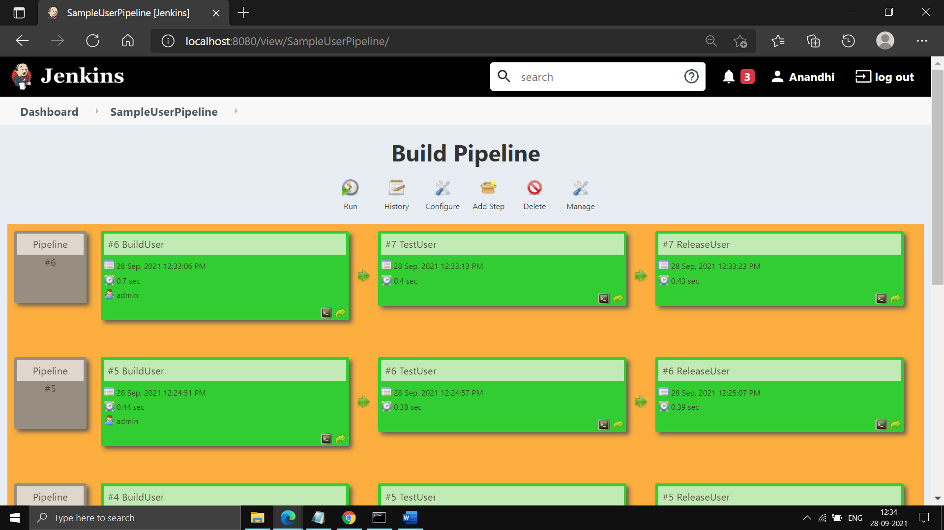

Creating a Maven Project :

1. Get a code from Remote Repo
2. Create a .war file using ‘package’ maven goal
3. Deploy this war into Tomcat.

Need to install 2 plugins,

Maven Integration plugin

Deploy to a container

Install both the plugins.

To create a Maven Project :

1. Get Source code from Git repo :

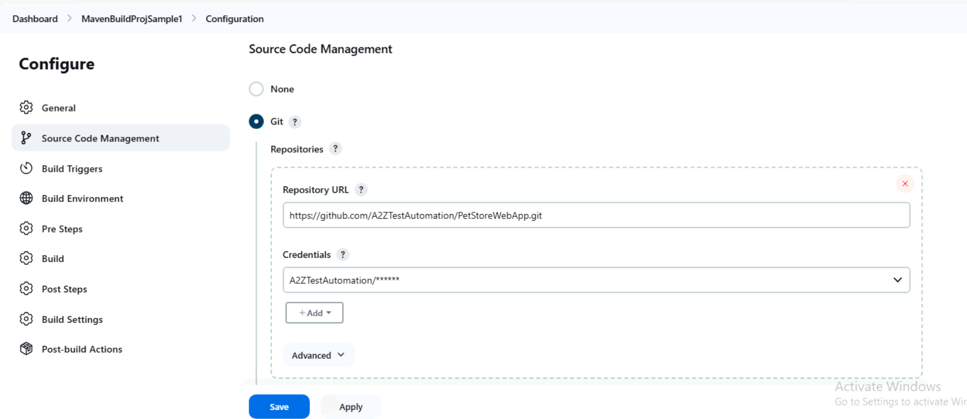

1. Generate a .war using maven goal :

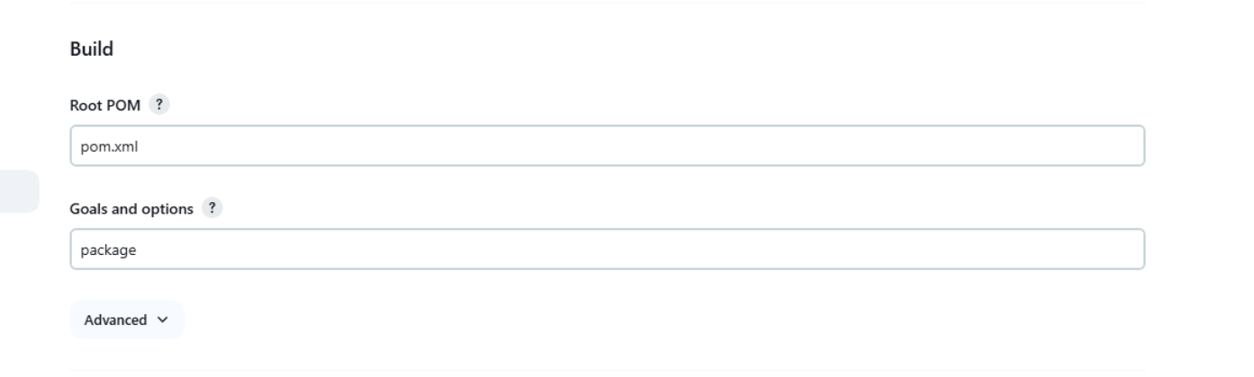

1. Deploy into tomcat server :

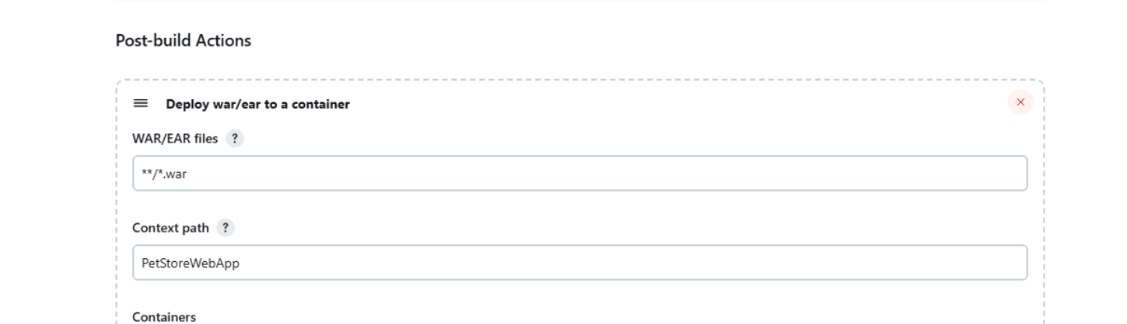

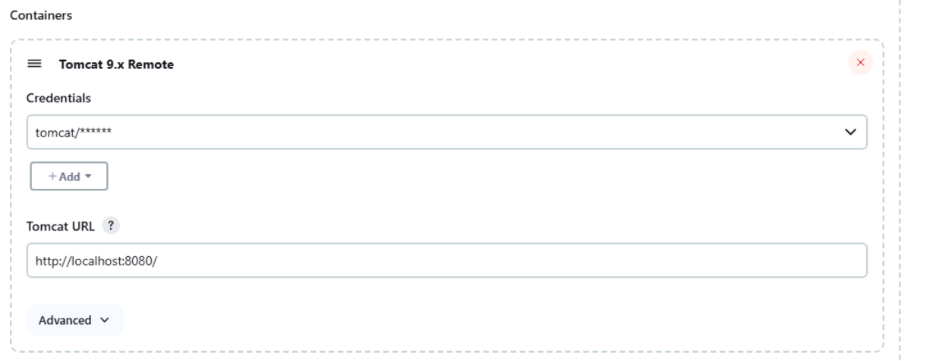

Ensure tomcat server is up and running and also added a role in conf/tomcat-users.xml file.

Now launch application in tomcat http://localhost:8090/PetStoreWebApp.